Mendix Intermediate Developer Certification - Exam Guide

July 2024
Mendix Academy
v. 3.0

Table of Contents:
Introduction 2
Prerequisites for Taking the Exam: 2
Preparing for the Exam 3
Resources 3
Accessing Your Registration 3
Setting Up the Exam Environment 4
Taking the Exam 4
Exam Rules 4
System Compatibility Check 5
Exam Expectations and Format 6
Beginning and Concluding Your Exam 6
Encountering Issues 6
Results 7
Receiving Your Exam Results 7
Retaking the Exam 7
Cooling Period 7
Frequently Asked Questions 7

Introduction
Are you ready to take the Intermediate Developer Certification exam?
This certification proves you have the foundational knowledge and practical experience to seamlessly integrate into operational teams. It highlights your ability to effectively contribute to Mendix projects by applying your skills across every stage of the project development lifecycle.

Prerequisites for Taking the Exam:
- Hold the Rapid Developer Certification.
- Meet the minimum System requirements specified by our exam platform.
- Register for the exam by clicking on "Get Certified" on the Intermediate Developer Certification page.

Preparing for the Exam

Resources
To prepare for the Intermediate Developer Certification exam, explore the learning paths available on the Mendix Academy. Scroll down on the Registration page to discover the topics you need to master before taking the exam.
Additionally, these topics may be covered in courses provided by Mendix Training Partners. You can explore the available courses here.
If you have any questions about the topics and the content while preparing for the exam, please feel free to contact us at academy@mendix.com. We will be happy to assist you with your queries.

Accessing Your Registration
After registering, you will be directed to a new page with a button to start the exam.
If you do not want to start the exam immediately, simply close the window. When you are ready, access My Exam Registrations in Mendix Academy (as shown below). There, you will find an overview of your exam registrations, and a link to start the exam.
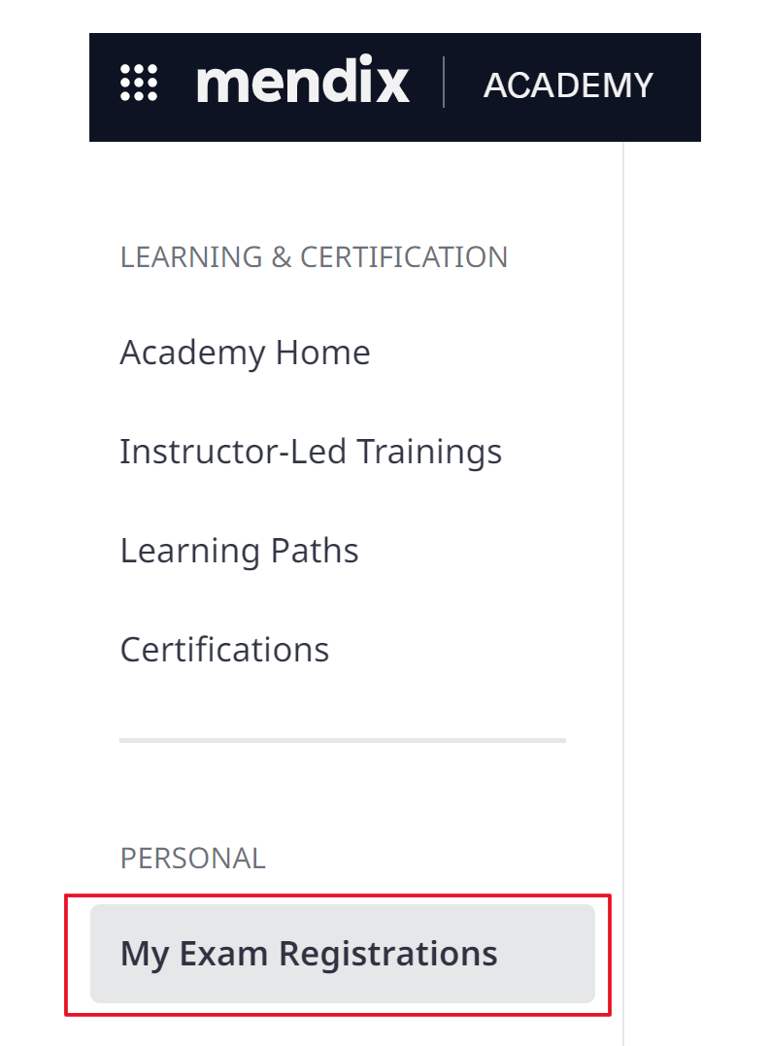
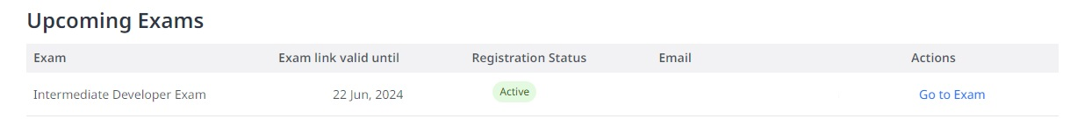
Alternatively, you can access the exam through the registration confirmation email you received. Simply click on the “Start the Exam!” button embedded in the email.
You have 30 days from the time of registration to take the exam. The exam link is valid for one attempt only.

Setting Up the Exam Environment
Below are key actions to ensure a smooth experience during the exam:
- Ensure your operating system and web browser are up to date. The exam will open in your default browser. For the best experience, please use Google Chrome, Mozilla Firefox, or Microsoft Edge.
- Confirm with your internet and power provider that there will be no disruptions during the time you will be attempting the certification exam.
- Ensure your webcam is fully functional as you will be required to be visible throughout the exam.
- Use only one monitor. The use of multiple monitors is not allowed.
- Choose a quiet and comfortable environment, free from distractions. Allocate 15 minutes for preparation before logging in and ensure you have adequate time for the exam itself.

Taking the Exam

Exam Rules
This is a closed-book exam, meaning the use of resources is not allowed. We recommend thorough preparation beforehand to ensure you are ready.
The following actions are prohibited during the exam:
- Recording the exam (including, but not limited to, screenshots, photographs, video recording, and copying text). This is also classified as theft from Mendix/Siemens.
- Using a document with questions and/or answers. This is also classified as theft from Mendix/Siemens.
- Using notes (includes both physical and virtual copies).
- Using a second monitor/computer.
- Using electronic devices. The platform will track and detect the presence of mobile phones, tablets, etc.
- Using headphones.
- Navigating away from the exam window.
- Permitting others to be present during the exam. Any sounds, objects, or individuals located behind a candidate will be flagged.
- Using communication platforms (Teams, Slack, Zoom, WhatsApp, social media, etc).
- Physically leaving the desk for longer than 2 minutes. Distractions (e.g., not looking at the screen) will be flagged.
- Blocking or adjusting the camera so that you are no longer visible during the exam could lead to your exam being invalidated.
- Reading the questions out loud.
- Speaking with other people in the room.
- Opening any application outside of the exam environment.
- Clicking the "Stop Sharing" button during the exam will instantly terminate your session, marking your attempt as unsuccessful.
- Using web translation services (i.e., Google Translate).

Note: During the exam, you will receive four warnings for any rule violations. If you receive a fifth warning, your exam will be automatically terminated.
Examples of rule violations:
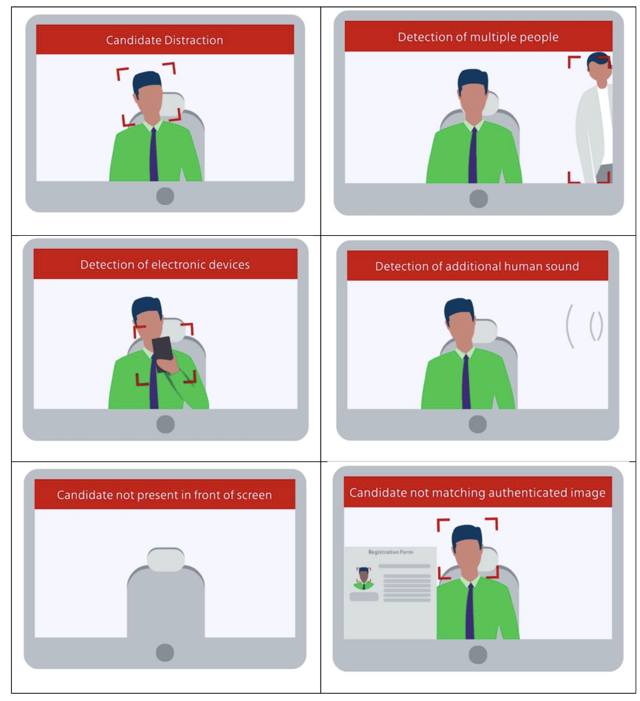
The exam is recorded and monitored to ensure rules compliance. Exam reviewers have the authority to invalidate exam results and impose bans on candidates suspected of rule violations.

System Compatibility Check
Before starting the exam, please perform the System Compatibility check provided by the exam platform. The link for this check is located on the exam page, right above the “Start the exam” button. Completing this step ensures that your system is ready for the exam.
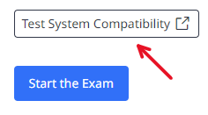

Exam Expectations and Format
You have 30 days from the time of registration to take the exam. Please be aware that once the 30-day period expires, the exam link will no longer be valid, and the exam fee is non-refundable.
This is a proctored exam. During the exam, your screen will be monitored and recorded. Once the time is up, all your answers will be submitted automatically.
To pass the exam, you must achieve a minimum score of 75%. The exam consists of 50 multiple-choice questions and has a 90-minute time limit. There is no minimum score required for each section.
You must adhere to Mendix exam rules. Violating these rules will nullify your exam results and grant you a three-month ban from taking any Mendix exams. If this happens, you will receive an email detailing the rule violation and the disqualification. Additionally, we may inform your employer about the violation and subsequent disqualification.

Beginning and Concluding Your Exam
Once you have confirmed that your system meets the requirements and you are ready to begin your exam, follow these steps:
- Access the Exam Page: Log in to Mendix Academy and navigate to the exam page. You will find your registration under the “My Exam Registrations” tab.
- Start the Exam: Look for the blue “Start Test” button on the exam page. Click it to initiate the exam.
Note: For detailed guidance on using the exam platform, please visit the “Attempting a Proctored Test” section in the exam platform provider support page.
To conclude your exam:
- Click on the "Finish Test" button to save your responses.
- If the exam time expires, it will end automatically, and your preliminary results will be displayed on the screen.
- You may then close your browser.

Encountering Issues
If you meet the minimum system requirements and continue to experience technical difficulties with your camera, microphone, or system, please contact our exam platform provider’s help desk at mettl-support@mercer.com.

Results

Receiving Your Exam Results
You will see a screen with your preliminary score when you complete the exam.
The Mendix Academy team will then carefully review your exam to ensure compliance with all rules and conditions. You can anticipate receiving your official results via email within three business days. You will receive a certificate upon passing.

Retaking the Exam

Cooling Period
If you do not pass the exam on your first attempt, you must wait one week before retaking it. There will be a two-week waiting period for subsequent attempts.
Each attempt requires paying a new exam fee. Therefore, we encourage you to prepare thoroughly before taking the exam.

Frequently Asked Questions

Before the Exam
- I’m getting an error that the exam link has expired.
The exam link is valid for 30 days. After this period, the link becomes invalid, requiring you to register again and pay the exam fee, as exams are non-refundable.
- Can I forward my exam link to another email address?
The exam link will not work if you forward the registration confirmation email to another email address. If you need to take the exam on a different computer, copy the exam link only. Please note that exam links are personal and should only be used by the designated recipient.
- Can you send the registration confirmation email to an email address that is not linked to my Mendix Account?
Although we cannot resend the email directly, you can access the exam on another computer if you wish to, by copying the exam link.

During the Exam
- I need help with a question.
During the exam, trust your own judgment. Consulting others is prohibited.
- My internet/electricity/camera/microphone/etc. stopped working.
Please see the Encountering Issues section of this document.
- Can I play music while taking the exam?
Playing music is not allowed, nor wearing headphones during the exam.
- Can I use ear plugs?
Using earplugs during the exam is not allowed, as they can be difficult to distinguish from modern headphone styles.
- The images in the exam are hard to see.
To view the image more clearly, click on it and consider adjusting your screen resolution.
- The images in the exam are not loading.
Please refer to the system requirements documentation provided by our exam platform provider and ensure that your system meets these requirements. If you meet these, and encounter further issues, please reach out to the help desk of our exam platform provider at mettl-support@mercer.com.
- I clicked too quickly at the end of the exam and missed seeing my score.
No problem! Your score will be sent to you later. Please consult the “Receiving your Exam Results” section in the document.

After the Exam
- Can I see which questions I got wrong?
We exclusively share your overall score along with your score for each section of the exam. Please note that we do not disclose specific details about the exam questions and their corresponding answers.
- I achieved an overall score of 74%. Is there any possibility of passing with this score?
A minimum of 75% is required to pass.
- Can I take the exam again if I don’t pass?
Yes, you can. If you don’t pass the exam on your first attempt, you’ll need to wait one week before retaking it. For subsequent attempts, there will be a two-week waiting period after each unsuccessful try. Each attempt requires paying a new exam fee.
- I believe there is an error in one of the exam questions.
Please email us at academy@mendix.com with any details you remember about the question and the exam section. Note that copying or taking screenshots of any exam questions is prohibited. We continuously evaluate the performance of exam questions to ensure they are accurate, well-worded, and appropriate for the exam level.
Is your question not listed here? Please reach out to academy@mendix.com.

